Week 4
Q1. Create a dictionary of student names and marks. Display students scoring above 75.
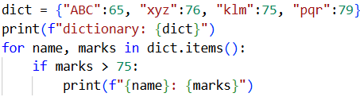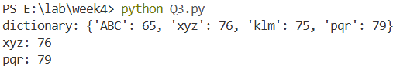
Q2. Write a program to sort a list in ascending and descending order.
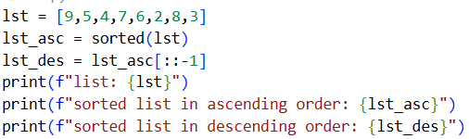
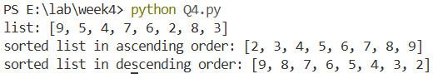
Q3. Write HTML code to generate the following output: 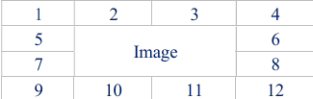
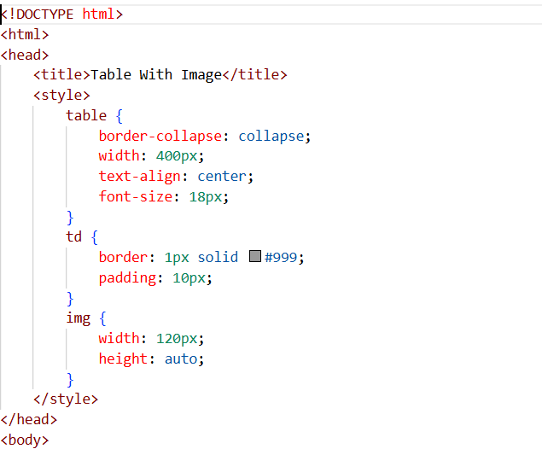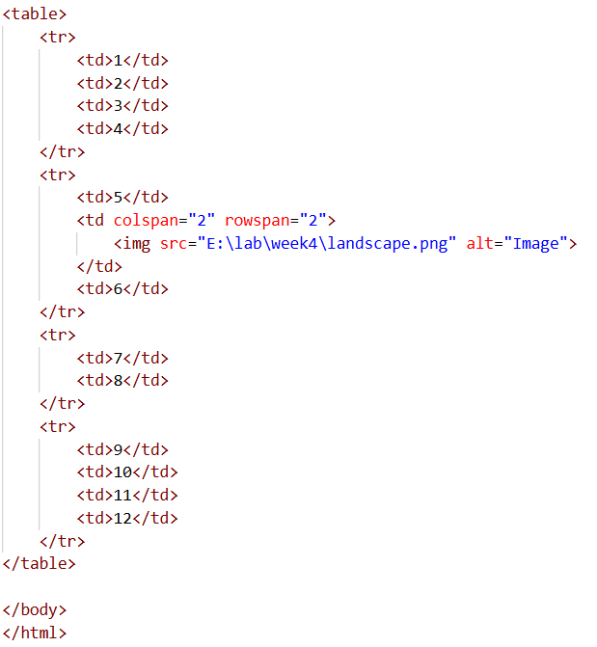
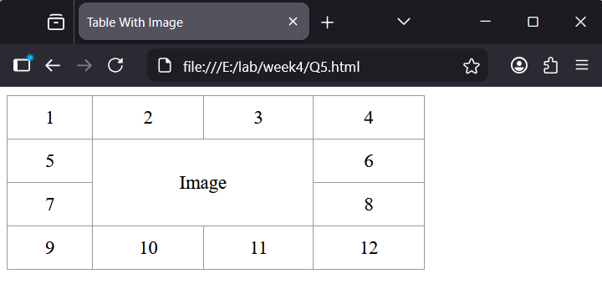
Q4. Write an HTML code to develop a Web page having two frames that divide the Web page into two equal rows and then divide the second row into two equal columns, then fill each frame with a different background color.
